**STUDENT NAME: P. HASINI**

**REG NUMBER : 192111535**

**SUBJECT NAME : OPERATING SYSTEM WITH DESIGN PRINCIPLES**

**SUBJECT CODE : CSA0470**

**1.SYSTEM CALLS**

#include<stdio.h>

#include<unistd.h>

#include<sys/types.h>

int main()

{

pid_t p;

printf("before fork\n");

p=fork();

if(p==0)

{

printf("I am child having id %d\n",getpid());

printf("My parent's id is %d\n",getppid());

}

else{

printf("My child's id is %d\n",p);

printf("I am parent having id %d\n",getpid());

}

printf("Common\n");

}

**OUTPUT**

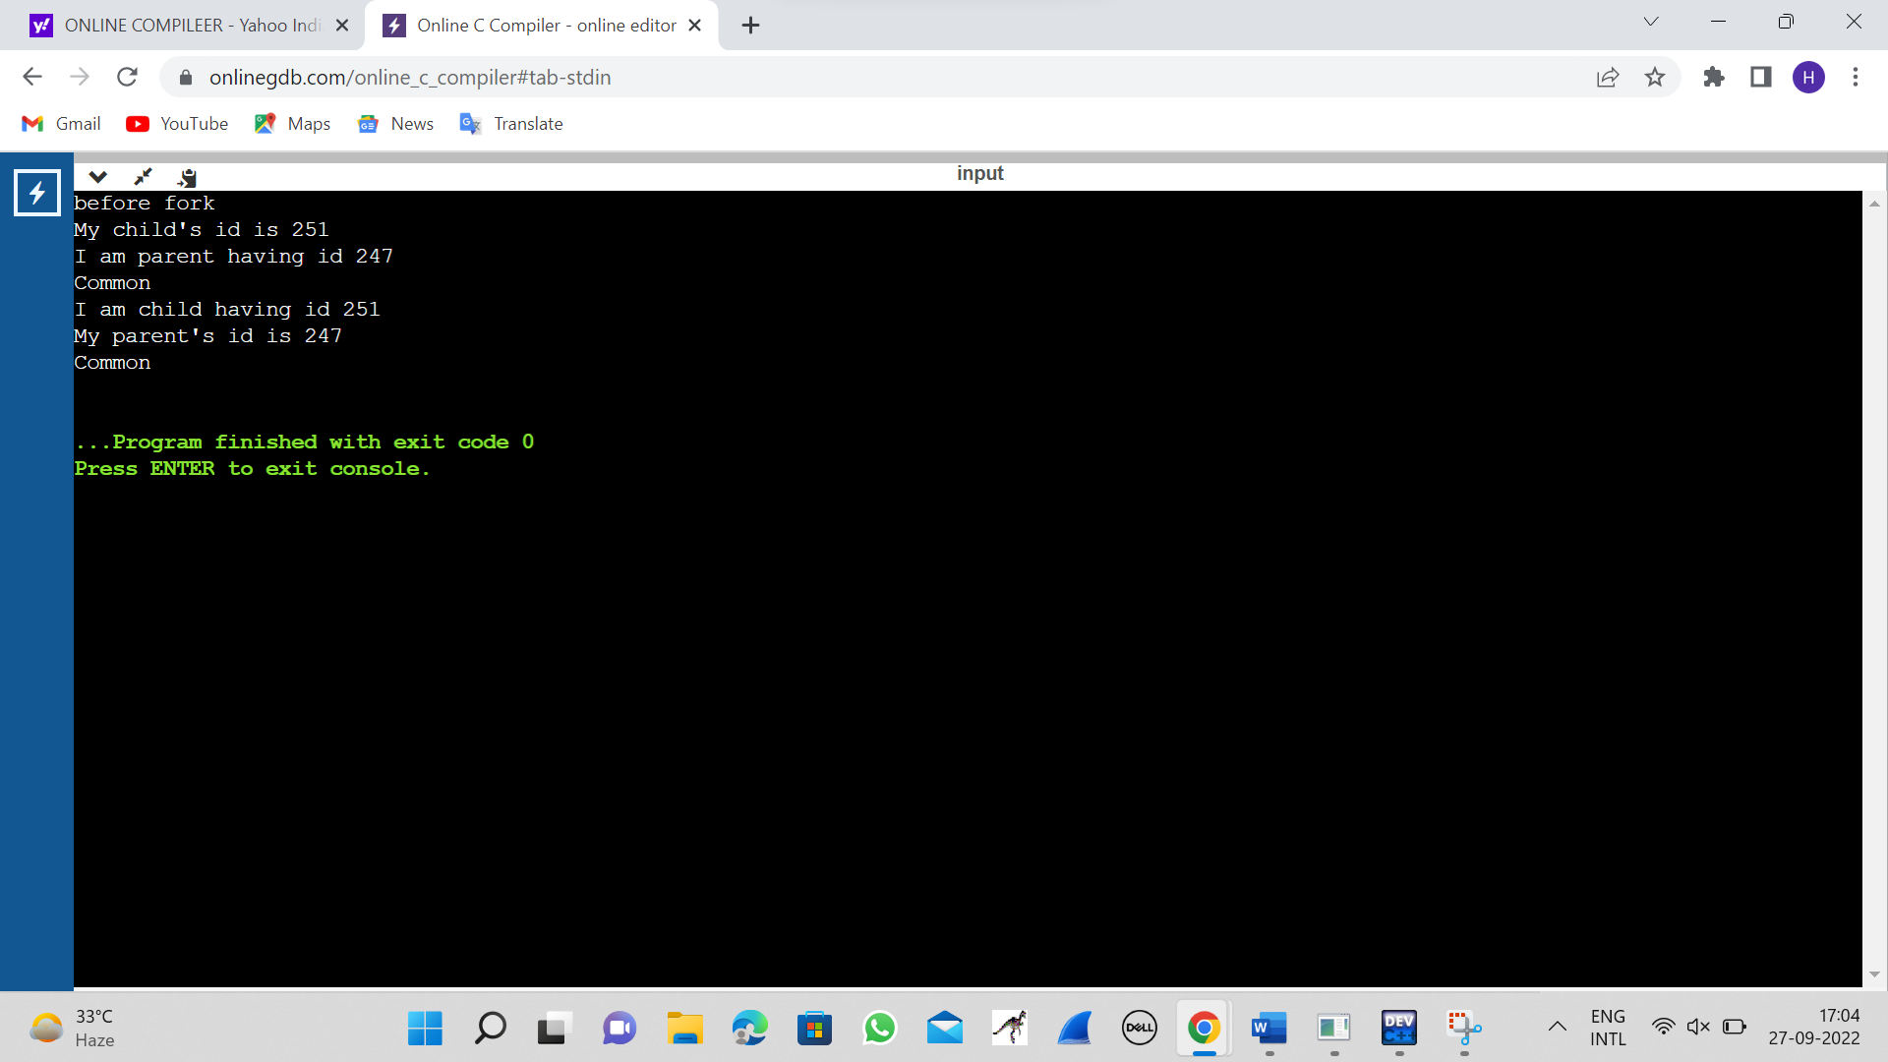

**2.FILE COPYING**

#include <stdio.h>

#include <stdlib.h>

int main(){

FILE *fptr1, *fptr2;

char filename[100], c;

printf("Enter the filename to open for reading \n");

scanf("%s",filename);

fptr1 = fopen(filename, "r");

if (fptr1 == NULL){

printf("Cannot open file %s \n", filename);

exit(0);

}

printf("Enter the filename to open for writing \n");

scanf("%s", filename);

fptr2 = fopen(filename, "w");

if (fptr2 == NULL){

printf("Cannot open file %s \n", filename);

exit(0);

}

c = fgetc(fptr1);

while (c != EOF){

fputc(c, fptr2);

c = fgetc(fptr1);

}

printf("\nContents copied to %s", filename);

fclose(fptr1);

fclose(fptr2);

return 0;

}

**OUTPUT**

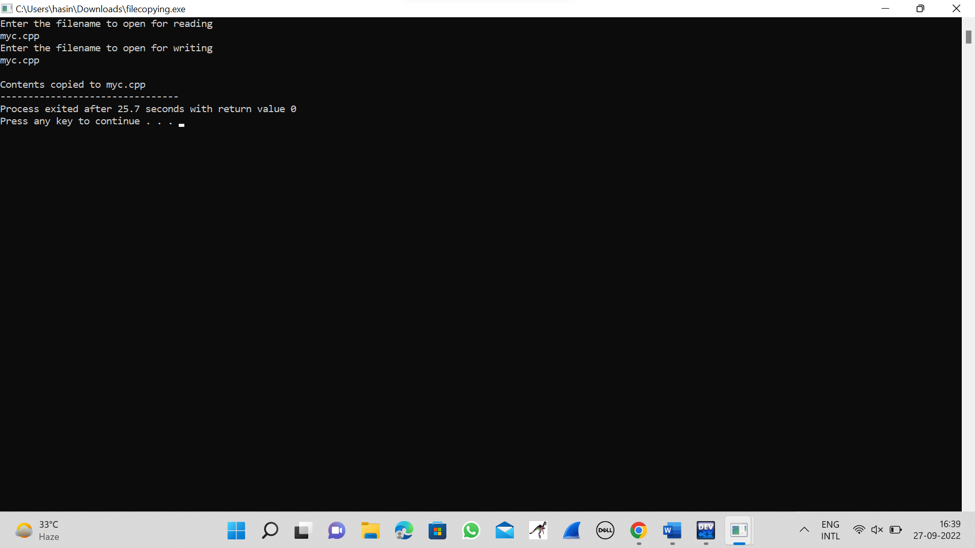

**3.FIRST COME FIRST SERVE(FCFS)**

#include<stdio.h>

int main()

{

int bt[10]={0},at[10]={0},tat[10]={0},wt[10]={0},ct[10]={0};

int n,sum=0;

float totalTAT=0,totalWT=0;

printf("Enter number of processes ");

scanf("%d",&n);

printf("Enter arrival time and burst time for each process\n\n");

for(int i=0;i<n;i++)

{

printf("Arrival time of process[%d] ",i+1);

scanf("%d",&at[i]);

printf("Burst time of process[%d] ",i+1);

scanf("%d",&bt[i]);

printf("\n");

}

for(int j=0;j<n;j++)

{

sum+=bt[j];

ct[j]+=sum;

}

for(int k=0;k<n;k++)

{

tat[k]=ct[k]-at[k];

totalTAT+=tat[k];

}

for(int k=0;k<n;k++)

{

wt[k]=tat[k]-bt[k];

totalWT+=wt[k];

}

printf("Solution: \n\n");

printf("P#\t AT\t BT\t CT\t TAT\t WT\t\n\n");

for(int i=0;i<n;i++)

{

printf("P%d\t %d\t %d\t %d\t %d\t %d\n",i+1,at[i],bt[i],ct[i],tat[i],wt[i]);

}

printf("\n\nAverage Turnaround Time = %f\n",totalTAT/n);

printf("Average WT = %f\n\n",totalWT/n);

return 0;

}

**OUTPUT**

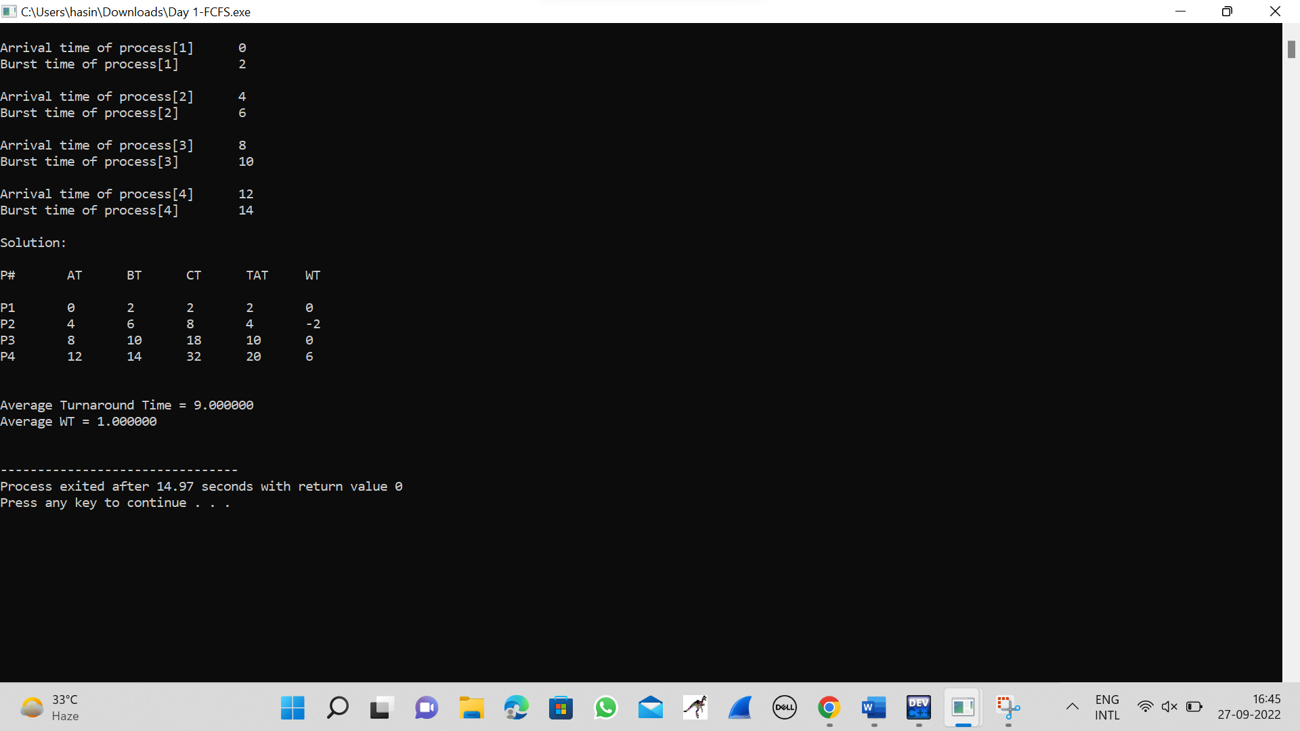

**4.SHORTEST JOB FIRST(SJF)**

#include <stdio.h>

int main()

{

int A[100][4];

int i, j, n, total = 0, index, temp; float avg_wt, avg_tat;

printf("Enter number of process: "); scanf("%d", &n);

printf("Enter Burst Time:\n");

for (i = 0; i < n; i++) {

printf("P%d: ", i + 1); scanf("%d", &A[i][1]); A[i][0] = i + 1;

}

for (i = 0; i < n; i++) {

index = i;

for (j = i + 1; j < n; j++)

if (A[j][1] < A[index][1]) index = j;

temp = A[i][1]; A[i][1] = A[index][1]; A[index][1] = temp;

temp = A[i][0];

A[i][0] = A[index][0]; A[index][0] = temp;

}

A[0][2] = 0;

for (i = 1; i < n; i++) {

A[i][2] = 0;

for (j = 0; j < i; j++)

A[i][2] += A[j][1];

total += A[i][2];

}

avg_wt = (float)total / n; total = 0;

printf("P BT WT TAT\n"); for (i = 0; i < n; i++) {

A[i][3] = A[i][1] + A[i][2];

total += A[i][3];

printf("P%d %d %d %d\n", A[i][0], A[i][1], A[i][2], A[i][3]);

}

avg_tat = (float)total / n;

printf("Average Waiting Time= %f", avg_wt); printf("\nAverage Turnaround Time= %f", avg_tat);

}

**OUTPUT**

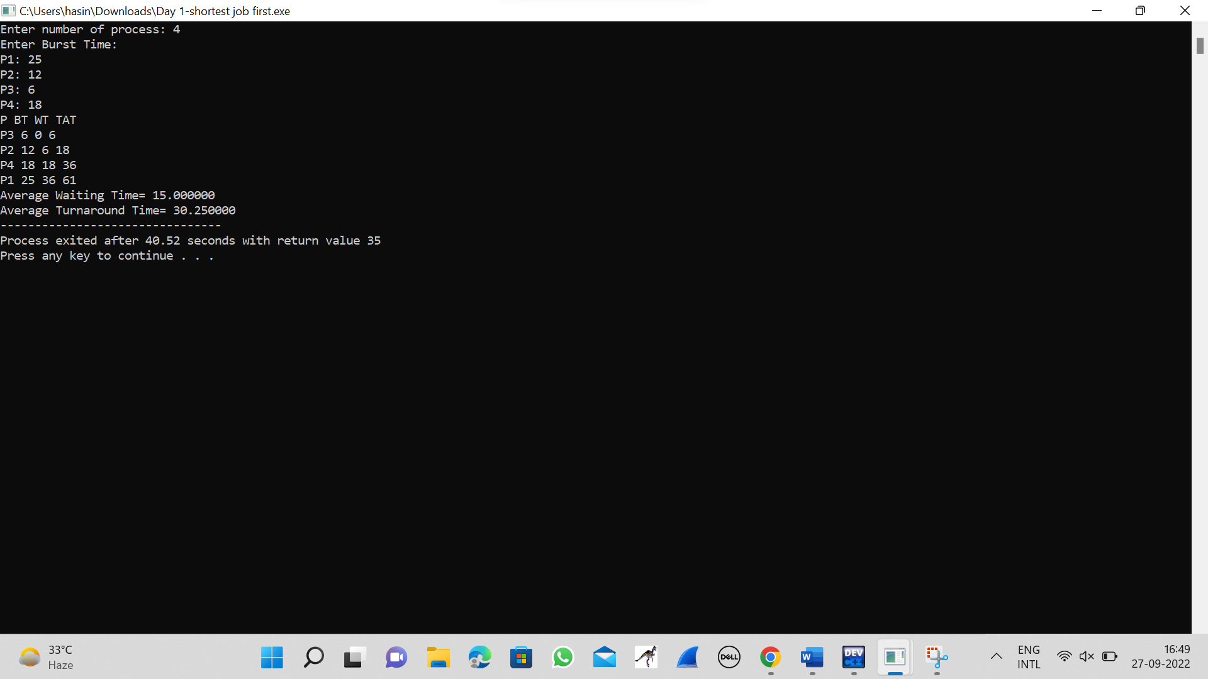

**5.PRIORITY SCHEDULLING**

#include<stdio.h>

struct priority_scheduling {

char process_name;

int burst_time;

int waiting_time;

int turn_around_time;

int priority;

};

int main() {

int number_of_process;

int total = 0;

struct priority_scheduling temp_process;

int ASCII_number = 65;

int position;

float average_waiting_time;

float average_turnaround_time;

printf("Enter the total number of Processes: ");

scanf("%d", & number_of_process);

struct priority_scheduling process[number_of_process];

printf("\nPlease Enter the Burst Time and Priority of each process:\n");

for (int i = 0; i < number_of_process; i++) {

process[i].process_name = (char) ASCII_number;

printf("\nEnter the details of the process %c \n", process[i].process_name);

printf("Enter the burst time: ");

scanf("%d", & process[i].burst_time);

printf("Enter the priority: ");

scanf("%d", & process[i].priority);

ASCII_number++;

}

for (int i = 0; i < number_of_process; i++) {

position = i;

for (int j = i + 1; j < number_of_process; j++) {

if (process[j].priority > process[position].priority)

position = j;

}

temp_process = process[i];

process[i] = process[position];

process[position] = temp_process;

}

process[0].waiting_time = 0;

for (int i = 1; i < number_of_process; i++) {

process[i].waiting_time = 0;

for (int j = 0; j < i; j++) {

process[i].waiting_time += process[j].burst_time;

}

total += process[i].waiting_time;

}

average_waiting_time = (float) total / (float) number_of_process;

total = 0;

printf("\n\nProcess_name \t Burst Time \t Waiting Time \t Turnaround Time\n");

printf("------------------------------------------------------------\n");

for (int i = 0; i < number_of_process; i++) {

process[i].turn_around_time = process[i].burst_time + process[i].waiting_time;

total += process[i].turn_around_time;

printf("\t %c \t\t %d \t\t %d \t\t %d", process[i].process_name, process[i].burst_time, process[i].waiting_time, process[i].turn_around_time);

printf("\n-----------------------------------------------------------\n");

}

average_turnaround_time = (float) total / (float) number_of_process;

printf("\n\n Average Waiting Time : %f", average_waiting_time);

printf("\n Average Turnaround Time: %f\n", average_turnaround_time);

return 0;

}

**OUTPUT**

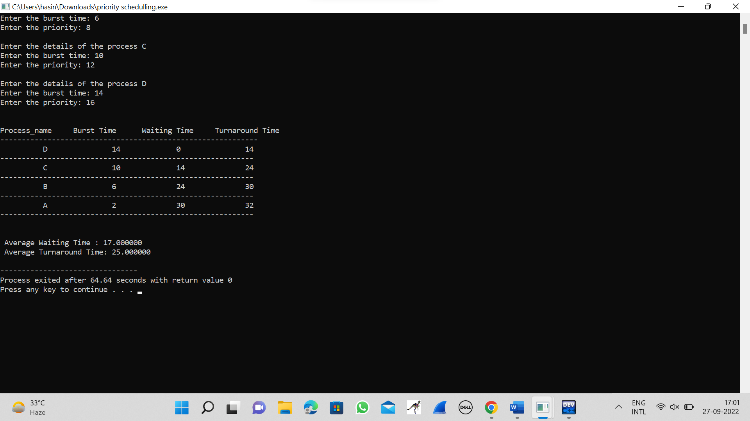

**6.ROUND ROBIN SCHEDULLING**

#include<stdio.h>

int main()

{

int count,j,n,time,remain,flag=0,time_quantum;

int wait_time=0,turnaround_time=0,at[10],bt[10],rt[10];

printf("Enter Total Process:\t ");

scanf("%d",&n);

remain=n;

for(count=0;count<n;count++)

{

printf("Enter Arrival Time and Burst Time for Process Process Number %d :",count+1);

scanf("%d",&at[count]);

scanf("%d",&bt[count]);

rt[count]=bt[count];

}

printf("Enter Time Quantum:\t");

scanf("%d",&time_quantum);

printf("\n\nProcess\t|Turnaround Time|Waiting Time\n\n");

for(time=0,count=0;remain!=0;)

{

if(rt[count]<=time_quantum && rt[count]>0)

{

time+=rt[count];

rt[count]=0;

flag=1;

}

else if(rt[count]>0)

{

rt[count]-=time_quantum;

time+=time_quantum;

}

if(rt[count]==0 && flag==1)

{

remain--;

printf("P[%d]\t|\t%d\t|\t%d\n",count+1,time-at[count],time-at[count]-bt[count]);

wait_time+=time-at[count]-bt[count];

turnaround_time+=time-at[count];

flag=0;

}

if(count==n-1)

count=0;

else if(at[count+1]<=time)

count++;

else

count=0;

}

printf("\nAverage Waiting Time= %f\n",wait_time*1.0/n);

printf("Avg Turnaround Time = %f",turnaround_time*1.0/n);

return 0;

}

**OUTPUT**

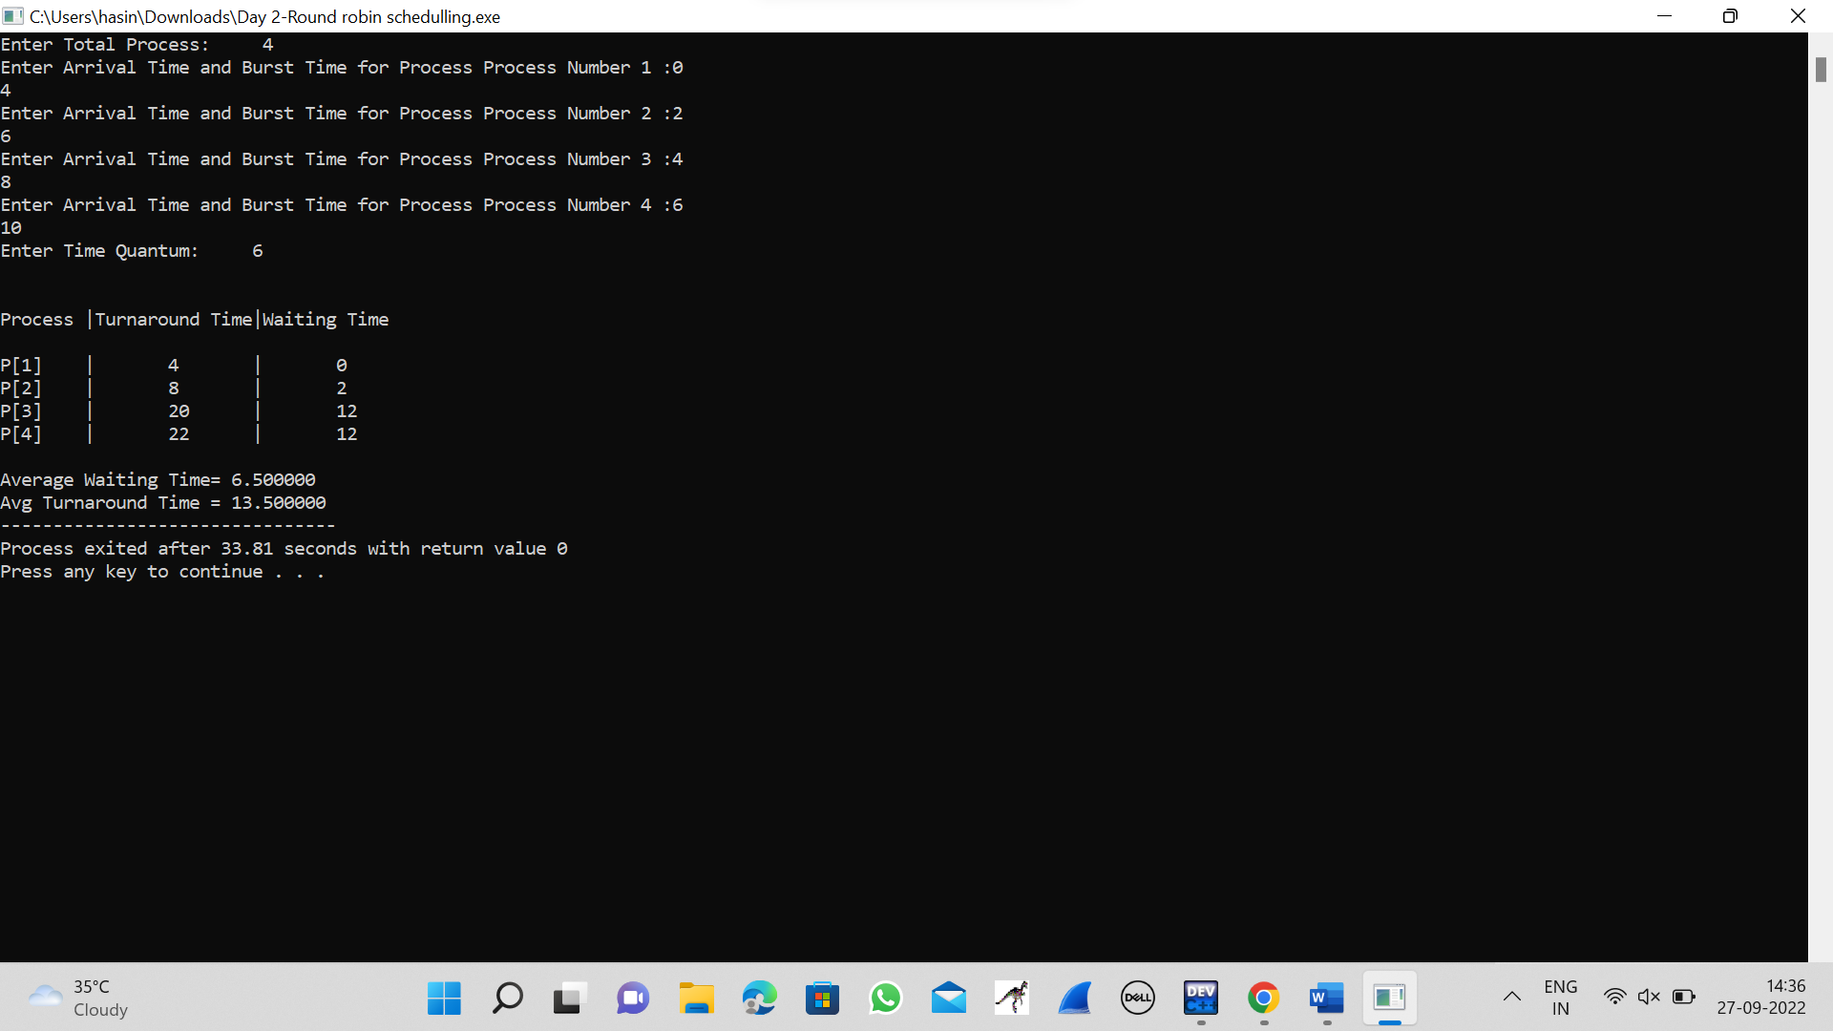

**7.INTER-PROCESS COMMUNICATION**

#include<stdio.h>

#include<stdlib.h>

#include<unistd.h>

#include<sys/shm.h>

#include<string.h>

int main()

{

int i;

void *shared_memory;

char buff[100];

int shmid;

shmid=shmget((key_t)2345, 1024, 0666|IPC_CREAT);

printf("Key of shared memory is %d\n",shmid);

shared_memory=shmat(shmid,NULL,0);

printf("Process attached at %p\n",shared_memory);

printf("Enter some data to write to shared memory\n");

read(0,buff,100);

strcpy(shared_memory,buff);

printf("You wrote : %s\n",(char *)shared_memory);

}

**OUTPUT**

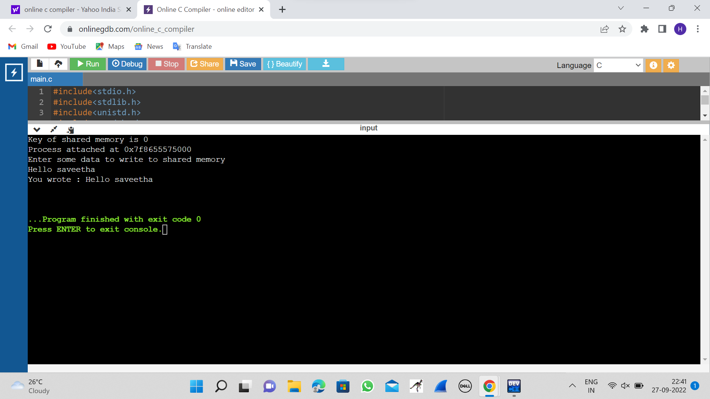

**8.MULTITHREADING**

#include <stdlib.h>

#include <unistd.h>

#include <pthread.h>

void *myThreadFun(void *vargp)

{

sleep(1);

printf("Printing GeeksQuiz from Thread \n");

return NULL;

}

int main()

{

pthread_t thread_id;

printf("Before Thread\n");

pthread_create(&thread_id, NULL, myThreadFun, NULL);

pthread_join(thread_id, NULL);

printf("After Thread\n");

exit(0);

}

**OUTPUT**

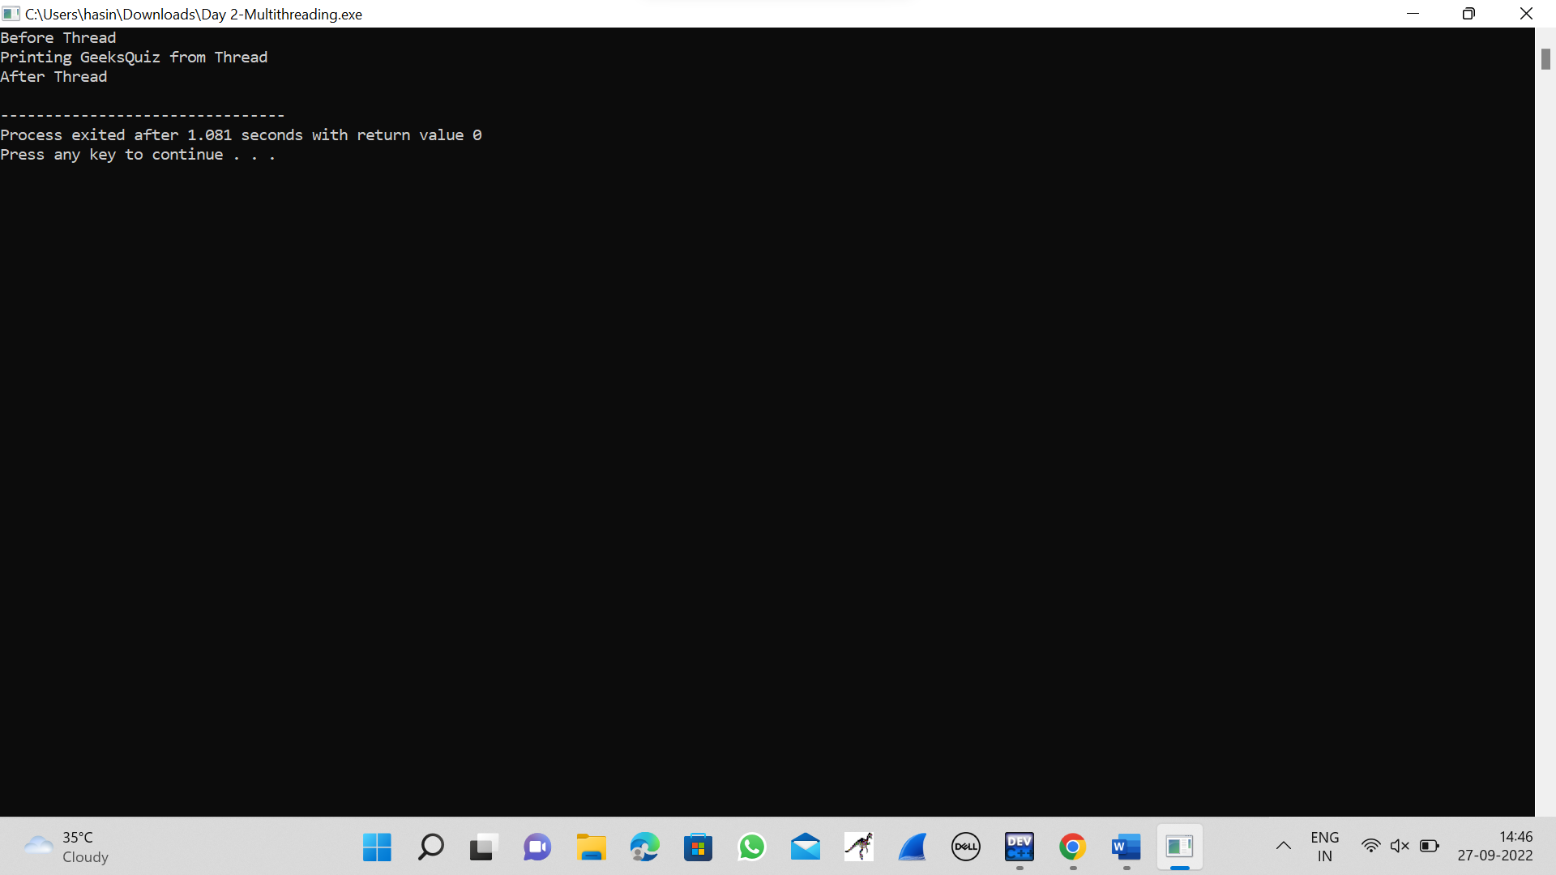

**9.DINING-PHILOSOPHERS**

#include<stdio.h>

#include<stdlib.h>

#include<pthread.h>

#include<semaphore.h>

#include<unistd.h>

sem_t room;

sem_t chopstick[5];

void * philosopher(void *);

void eat(int);

int main()

{

int i,a[5];

pthread_t tid[5];

sem_init(&room,0,4);

for(i=0;i<5;i++)

sem_init(&chopstick[i],0,1);

for(i=0;i<5;i++){

a[i]=i;

pthread_create(&tid[i],NULL,philosopher,(void *)&a[i]);

}

for(i=0;i<5;i++)

pthread_join(tid[i],NULL);

}

void * philosopher(void * num)

{

int phil=*(int *)num;

sem_wait(&room);

printf("\nPhilosopher %d has entered room",phil);

sem_wait(&chopstick[phil]);

sem_wait(&chopstick[(phil+1)%5]);

eat(phil);

sleep(2);

printf("\nPhilosopher %d has finished eating",phil);

sem_post(&chopstick[(phil+1)%5]);

sem_post(&chopstick[phil]);

sem_post(&room);

}

void eat(int phil)

{

printf("\nPhilosopher %d is eating",phil);

}

**OUTPUT**

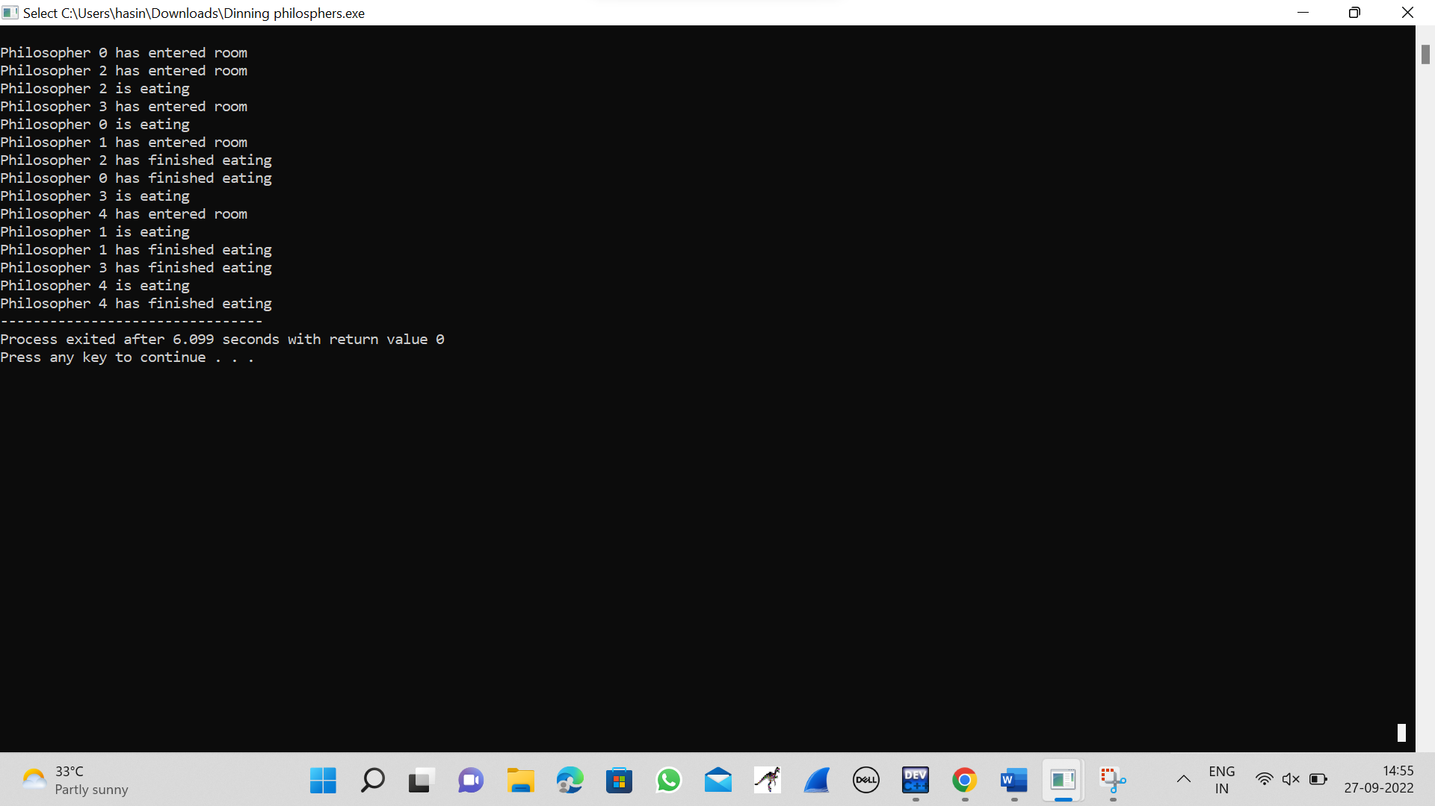

**10.MEMORY ALLOCATION USING FIRST FIT STRATEGY**

#include<stdio.h>

int main( )

{

int bsize[10], psize[10], bno, pno, flags[10], allocation[10], i, j;

for(i = 0; i < 10; i++)

{

flags[i] = 0;

allocation[i] = -1;

}

printf("Enter no. of blocks: ");

scanf("%d", &bno);

printf("\nEnter size of each block: ");

for(i = 0; i < bno; i++)

scanf("%d", &bsize[i]);

printf("\nEnter no. of processes: ");

scanf("%d", &pno);

printf("\nEnter size of each process: ");

for(i = 0; i < pno; i++)

scanf("%d", &psize[i]);

for(i = 0; i < pno; i++)

for(j = 0; j < bno; j++)

if(flags[j] == 0 && bsize[j] >= psize[i])

{

allocation[j] = i;

flags[j] = 1;

break;

}

printf("\nBlock no.\tsize\t\tprocess no.\t\tsize");

for(i = 0; i < bno; i++)

{

printf("\n%d\t\t%d\t\t", i+1, bsize[i]);

if(flags[i] == 1)

printf("%d\t\t\t%d",allocation[i]+1,psize[allocation[i]]);

else

printf("Not allocated");

}

}

**OUTPUT**

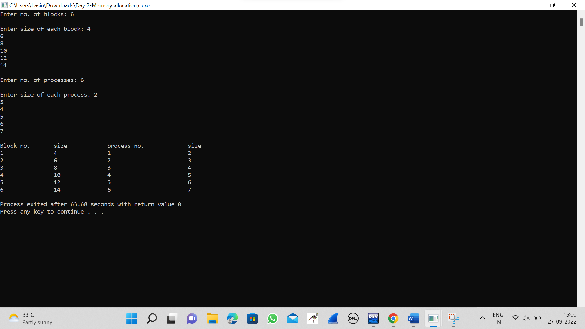

**11.SINGLE LEVEL DIRECTORY**

#include<conio.h>

#include<string.h>

void main()

{

int nf=0,i=0,j=0,ch;

char mdname[10],fname[10][10],name[10];

printf("Enter the directory name:");

scanf("%s",mdname);

printf("Enter the number of files:");

scanf("%d",&nf);

do

{

printf("Enter file name to be created:");

scanf("%s",name);

for(i=0;i<nf;i++)

{

if(!strcmp(name,fname[i]))

break;

}

if(i==nf)

{

strcpy(fname[j++],name);

nf++;

}

else

printf("There is already %s\n",name);

printf("Do you want to enter another file(yes - 1 or no - 0):");

scanf("%d",&ch);

}

while(ch==1);

printf("Directory name is:%s\n",mdname);

printf("Files names are:");

for(i=0;i<j;i++)

printf("\n%s",fname[i]);

getch();

}

**OUTPUT**

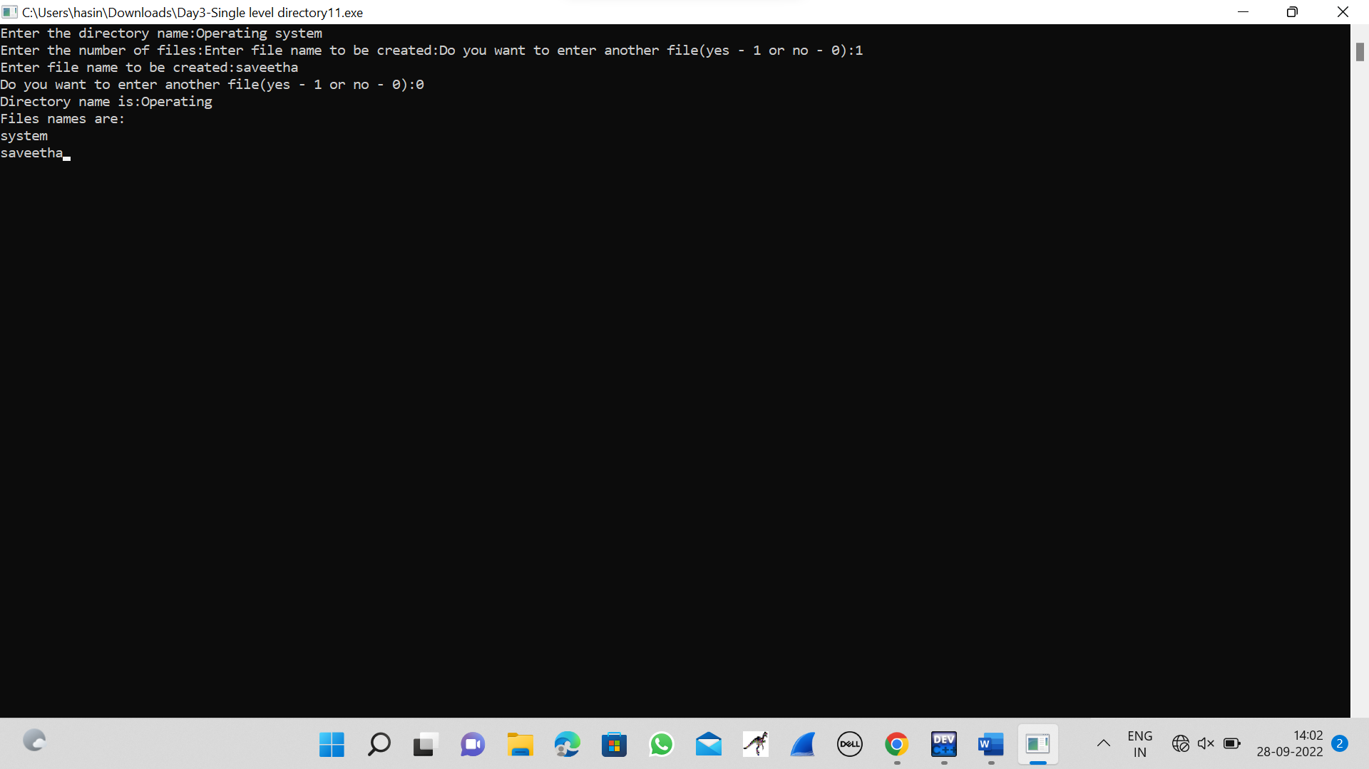

**12.TWO LEVEL DIRECTORY STRUCTURE**

#include<stdio.h>

#include<string.h>

#include<stdlib.h>

struct

{

char dname[10],fname[10][10];

int fcnt;

}dir[10];

void main()

{

int i,ch,dcnt,k;

char f[30], d[30];

dcnt=0;

while(1)

{

printf("1. Create Directory\t2. Create File\t3. Delete File");

printf("\n4. Search File\t\t5. Display\t6. Exit\tEnter your choice --");

scanf("%d",&ch);

switch(ch)

{

case 1: printf("\nEnter name of directory -- ");

scanf("%s", dir[dcnt].dname);

dir[dcnt].fcnt=0;

dcnt++;

printf("Directory created");

break;

case 2: printf("\nEnter name of the directory -- ");

scanf("%s",d);

for(i=0;i<dcnt;i++)

if(strcmp(d,dir[i].dname)==0)

{

printf("Enter name of the file -- ");

scanf("%s",dir[i].fname[dir[i].fcnt]);

dir[i].fcnt++;

printf("File created");

break;

}

if(i==dcnt)

printf("Directory %s not found",d);

break;

case 3: printf("\nEnter name of the directory -- ");

scanf("%s",d);

for(i=0;i<dcnt;i++)

{

if(strcmp(d,dir[i].dname)==0)

{

printf("Enter name of the file -- ");

scanf("%s",f);

for(k=0;k<dir[i].fcnt;k++)

{

if(strcmp(f, dir[i].fname[k])==0)

{

printf("File %s is deleted ",f);

dir[i].fcnt--;

strcpy(dir[i].fname[k],dir[i].fname[dir[i].fcnt]);

goto jmp;

}

}

printf("File %s not found",f);

goto jmp;

}

}

printf("Directory %s not found",d);

jmp : break;

case 4: printf("\nEnter name of the directory -- ");

scanf("%s",d);

for(i=0;i<dcnt;i++)

{

if(strcmp(d,dir[i].dname)==0)

{

printf("Enter the name of the file -- ");

scanf("%s",f);

for(k=0;k<dir[i].fcnt;k++)

{

if(strcmp(f, dir[i].fname[k])==0)

{

printf("File %s is found ",f);

goto jmp1;

}

}

printf("File %s not found",f);

goto jmp1;

}

}

printf("Directory %s not found",d);

jmp1: break;

case 5: if(dcnt==0)

printf("\nNo Directory's ");

else

{

printf("\nDirectory\tFiles");

for(i=0;i<dcnt;i++)

{

printf("\n%s\t\t",dir[i].dname);

for(k=0;k<dir[i].fcnt;k++)

printf("\t%s",dir[i].fname[k]);

}

}

break;

default:exit(0);

}

}

}

**OUTPUT**

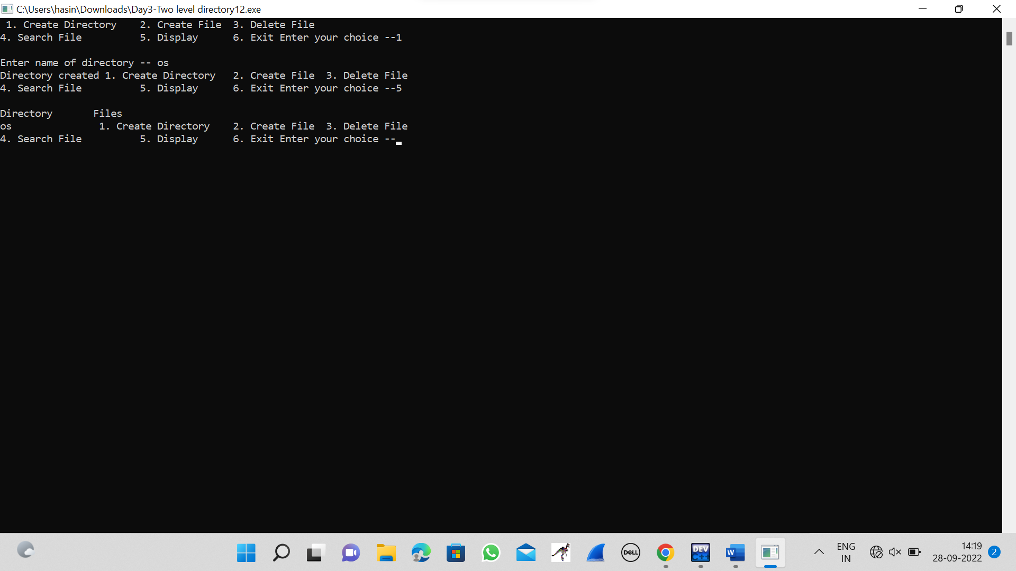

**13.RANDAM ACCESS FILE**

#include <stdio.h>

#include <stdlib.h>

#include <string.h>

#include <windows.h>

struct emp {

char name[50];

float salary;

int age;

int id;

};

struct emp e;

long int size = sizeof(e);

COORD cord = { 0, 0 };

void gotoxy(int x, int y)

{

cord.X = x;

cord.Y = y;

SetConsoleCursorPosition(

GetStdHandle(STD_OUTPUT_HANDLE),

cord);

}

FILE *fp, *ft;

void addrecord()

{

system("cls");

fseek(fp, 0, SEEK_END);

char another = 'y';

while (another == 'y') {

printf("\nEnter Name : ");

scanf("%s", e.name);

printf("\nEnter Age : ");

scanf("%d", &e.age);

printf("\nEnter Salary : ");

scanf("%f", &e.salary);

printf("\nEnter EMP-ID : ");

scanf("%d", &e.id);

fwrite(&e, size, 1, fp);

printf("\nWant to add another"

" record (Y/N) : ");

fflush(stdin);

scanf("%c", &another);

}

}

void deleterecord()

{

system("cls");

char empname[50];

char another = 'y';

while (another == 'y') {

printf("\nEnter employee "

"name to delete : ");

scanf("%s", empname);

ft = fopen("temp.txt", "wb");

rewind(fp);

while (fread(&e, size,

1, fp)

== 1) {

if (strcmp(e.name,

empname)

!= 0)

fwrite(&e, size, 1, ft);

}

fclose(fp);

fclose(ft);

remove("data.txt");

rename("temp.txt", "data.txt");

fp = fopen("data.txt", "rb+");

printf("\nWant to delete another"

" record (Y/N) :");

fflush(stdin);

another = getche();

}

}

void displayrecord()

{

system("cls");

rewind(fp);

printf("\n========================="

"==========================="

"======");

printf("\nNAME\t\tAGE\t\tSALARY\t\t"

"\tID\n",

e.name, e.age,

e.salary, e.id);

printf("==========================="

"==========================="

"====\n");

while (fread(&e, size, 1, fp) == 1)

printf("\n%s\t\t%d\t\t%.2f\t%10d",

e.name, e.age, e.salary, e.id);

printf("\n\n\n\t");

system("pause");

}

void modifyrecord()

{

system("cls");

char empname[50];

char another = 'y';

while (another == 'y') {

printf("\nEnter employee name"

" to modify : ");

scanf("%s", empname);

rewind(fp);

while (fread(&e, size, 1, fp) == 1) {

if (strcmp(e.name, empname) == 0) {

printf("\nEnter new name:");

scanf("%s", e.name);

printf("\nEnter new age :");

scanf("%d", &e.age);

printf("\nEnter new salary :");

scanf("%f", &e.salary);

printf("\nEnter new EMP-ID :");

scanf("%d", &e.id);

fseek(fp, -size, SEEK_CUR);

fwrite(&e, size, 1, fp);

break;

}

}

printf("\nWant to modify another"

" record (Y/N) :");

fflush(stdin);

scanf("%c", &another);

}

}

int main()

{

int choice;

fp = fopen("data.txt", "rb+");

if (fp == NULL) {

fp = fopen("data.txt", "wb+");

if (fp == NULL) {

printf("\nCannot open file...");

exit(1);

}

}

system("Color 3F");

printf("\n\n\n\n\t\t\t\t============="

"============================="

"===========");

printf("\n\t\t\t\t~~~~~~~~~~~~~~~~~~~"

"~~~~~~~~~~~~~~~~~~~~~~~~~~~~~"

"~~~~~");

printf("\n\t\t\t\t==================="

"============================="

"=====");

printf("\n\t\t\t\t[|:::>:::>:::>::> "

"EMPLOYEE RECORD <::<:::<:::"

"<:::|]\t");

printf("\n\t\t\t\t==================="

"============================="

"=====");

printf("\n\t\t\t\t~~~~~~~~~~~~~~~~~~~~"

"~~~~~~~~~~~~~~~~~~~~~~~~~~~~~~"

"~~~");

printf("\n\t\t\t\t====================="

"==============================\n");

printf("\n\n\n\t\t\t\t\t\t\t\t\t\t"

"Developer : @Sushant_Gaurav"

"\n\n\t\t\t\t");

system("pause");

while (1) {

system("cls");

gotoxy(30, 10);

printf("\n1. ADD RECORD\n");

gotoxy(30, 12);

printf("\n2. DELETE RECORD\n");

gotoxy(30, 14);

printf("\n3. DISPLAY RECORDS\n");

gotoxy(30, 16);

printf("\n4. MODIFY RECORD\n");

gotoxy(30, 18);

printf("\n5. EXIT\n");

gotoxy(30, 20);

printf("\nENTER YOUR CHOICE...\n");

fflush(stdin);

scanf("%d", &choice);

switch (choice) {

case 1:

addrecord();

break;

case 2:

deleterecord();

break;

case 3:

displayrecord();

break;

case 4:

modifyrecord();

break;

case 5:

fclose(fp);

exit(0);

break;

default:

printf("\nINVALID CHOICE...\n");

}

}

{

return 0;

}

}

**OUTPUT**

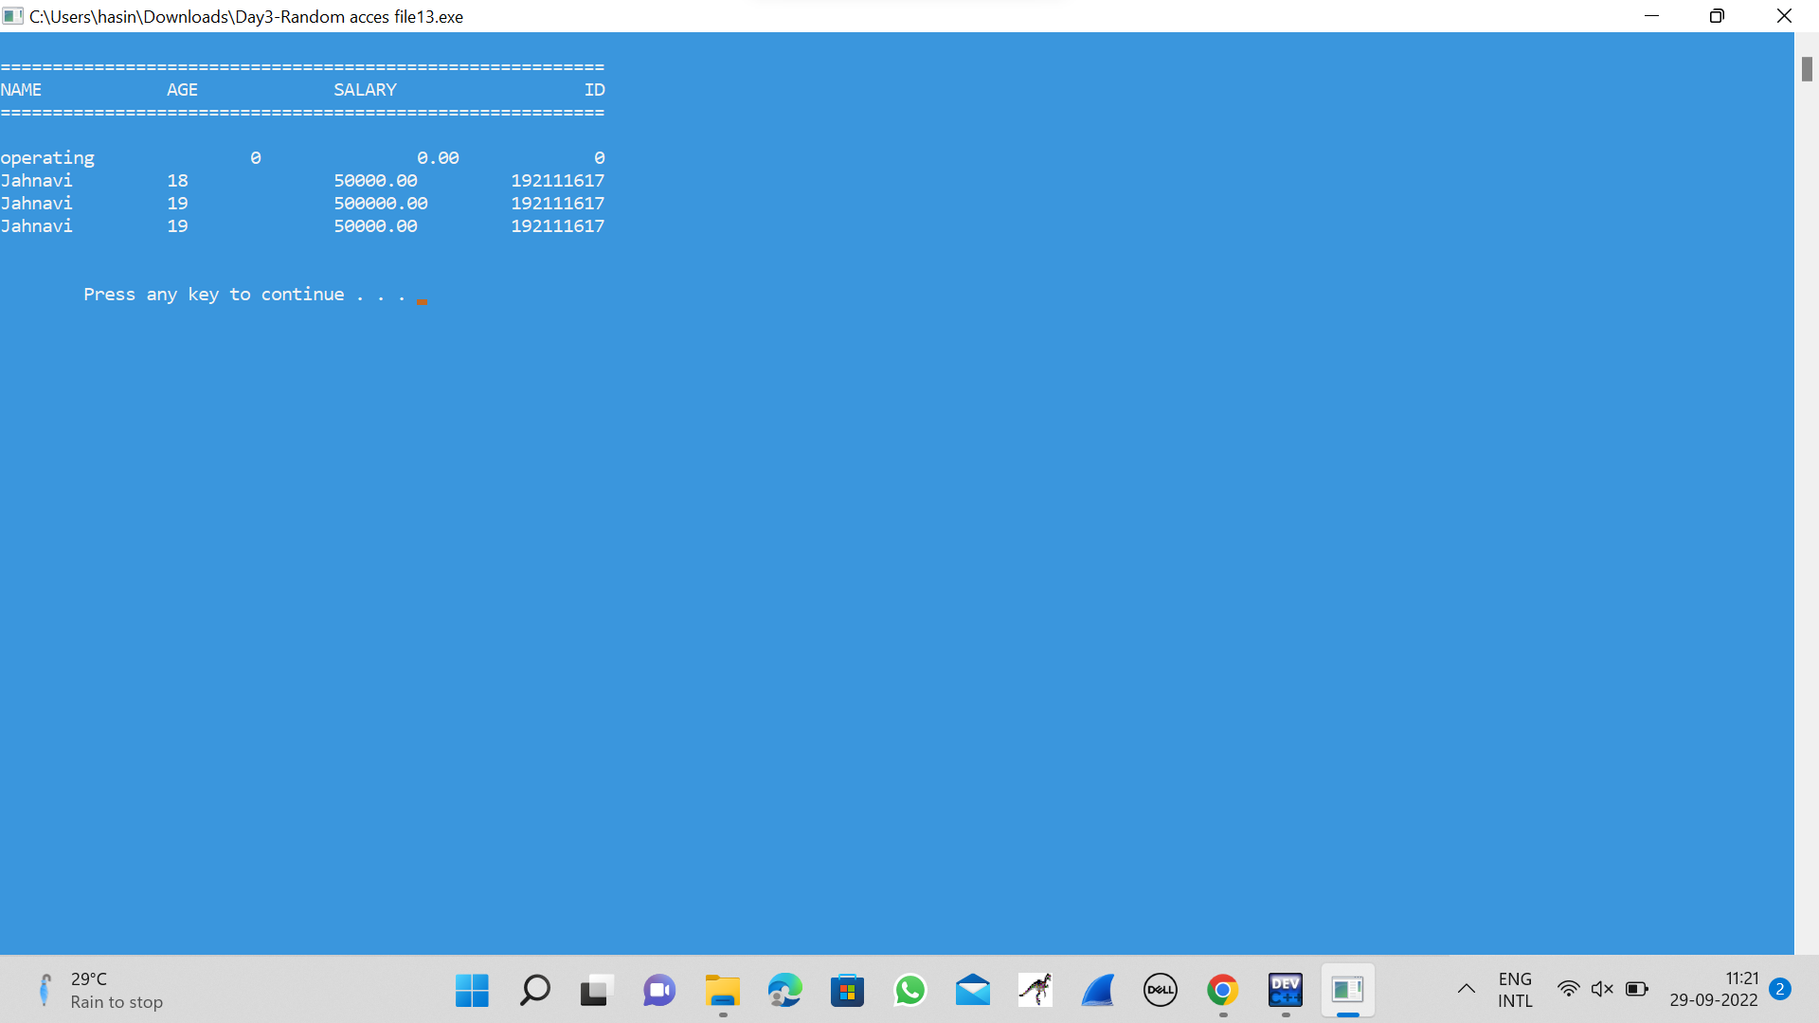

**14.BANKERS ALGORITHM**

#include <stdio.h>

#include <conio.h>

int main()

{

int Max[10][10], need[10][10], alloc[10][10], avail[10], completed[10], safeSequence[10];

int p, r, i, j, process, count;

count = 0;

printf("Enter the no of processes : ");

scanf("%d", &p);

for(i = 0; i< p; i++)

completed[i] = 0;

printf("Enter the no of resources : ");

scanf("%d", &r);

printf("Enter the Max Matrix for each process : \n");

for(i = 0; i < p; i++)

{

printf("For process %d : ", i + 1);

for(j = 0; j < r; j++)

scanf("%d", &Max[i][j]);

}

printf("Enter the allocation for each process : \n");

for(i = 0; i < p; i++)

{

printf("For process %d : ",i + 1);

for(j = 0; j < r; j++)

scanf("%d", &alloc[i][j]);

}

printf("Enter the Available Resources : ");

for(i = 0; i < r; i++)

scanf("%d", &avail[i]);

for(i = 0; i < p; i++)

for(j = 0; j < r; j++)

need[i][j] = Max[i][j] - alloc[i][j];

do

{

printf("\nMax matrix:\tAllocation matrix:\n");

for(i = 0; i < p; i++)

{

for( j = 0; j < r; j++)

printf("%d ", Max[i][j]);

printf("\t\t");

for( j = 0; j < r; j++)

printf("%d ", alloc[i][j]);

printf("\n");

}

process = -1;

for(i = 0; i < p; i++)

{

if(completed[i] == 0)

{

process = i ;

for(j = 0; j < r; j++)

{

if(avail[j] < need[i][j])

{

process = -1;

break;

}

}

}

if(process != -1)

break;

}

if(process != -1)

{

printf("\nProcess %d runs to completion!", process + 1);

safeSequence[count] = process + 1;

count++;

for(j = 0; j < r; j++)

{

avail[j] += alloc[process][j];

alloc[process][j] = 0;

Max[process][j] = 0;

completed[process] = 1;

}

}

}while(count != p && process != -1);

if(count == p)

{

printf("\nThe system is in a safe state!!\n");

printf("Safe Sequence : < ");

for( i = 0; i < p; i++)

printf("%d ", safeSequence[i]);

printf(">\n");

}

else

printf("\nThe system is in an unsafe state!!");

getch();

}

**OUTPUT**

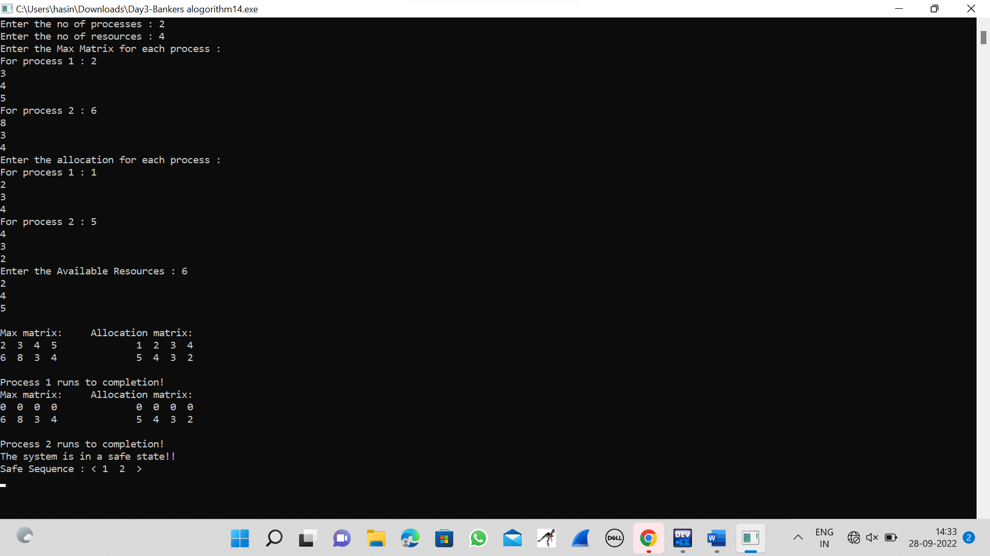

**15.PRODUCER-CONSUMER PROBLEM USING SEMAPHORES**

#include <stdio.h>

#include <stdlib.h>

int mutex = 1;

int full = 0;

int empty = 10, x = 0;

void producer()

{

--mutex;

++full;

--empty;

x++;

printf("\nProducer produces"

"item %d",

x);

++mutex;

}

void consumer()

{

--mutex;

--full;

++empty;

printf("\nConsumer consumes "

"item %d",

x);

x--;

++mutex;

}

int main()

{

int n, i;

printf("\n1. Press 1 for Producer"

"\n2. Press 2 for Consumer"

"\n3. Press 3 for Exit");

for (i = 1; i > 0; i++) {

printf("\nEnter your choice:");

scanf("%d", &n);

switch (n) {

case 1:

if ((mutex == 1)

&& (empty != 0)) {

producer();

}

else {

printf("Buffer is full!");

}

break;

case 2:

if ((mutex == 1)

&& (full != 0)) {

consumer();

}

else {

printf("Buffer is empty!");

}

break;

case 3:

exit(0);

break;

}

}

}

**OUTPUT**

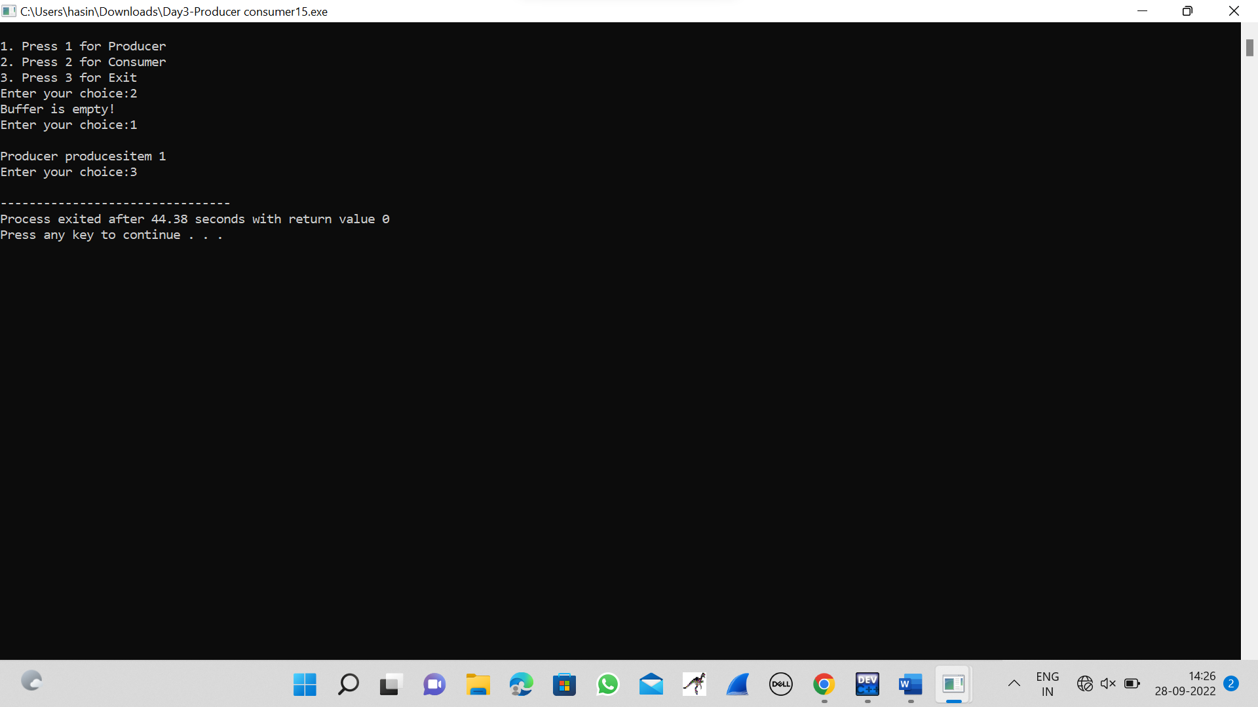

**16.FIRST IN FIRST OUT PAGING ALGORITHM**

#include <stdio.h>

int main()

{

int referenceString[10], pageFaults = 0, m, n, s, pages, frames;

printf("\nEnter the number of Pages:\t");

scanf("%d", &pages);

printf("\nEnter reference string values:\n");

for( m = 0; m < pages; m++)

{

printf("Value No. [%d]:\t", m + 1);

scanf("%d", &referenceString[m]);

}

printf("\n What are the total number of frames:\t");

{

scanf("%d", &frames);

}

int temp[frames];

for(m = 0; m < frames; m++)

{

temp[m] = -1;

}

for(m = 0; m < pages; m++)

{

s = 0;

for(n = 0; n < frames; n++)

{

if(referenceString[m] == temp[n])

{

s++;

pageFaults--;

}

}

pageFaults++;

if((pageFaults <= frames) && (s == 0))

{

temp[m] = referenceString[m];

}

else if(s == 0)

{

temp[(pageFaults - 1) % frames] = referenceString[m];

}

printf("\n");

for(n = 0; n < frames; n++)

{

printf("%d\t", temp[n]);

}

}

printf("\nTotal Page Faults:\t%d\n", pageFaults);

return 0;

}

**OUTPUT**

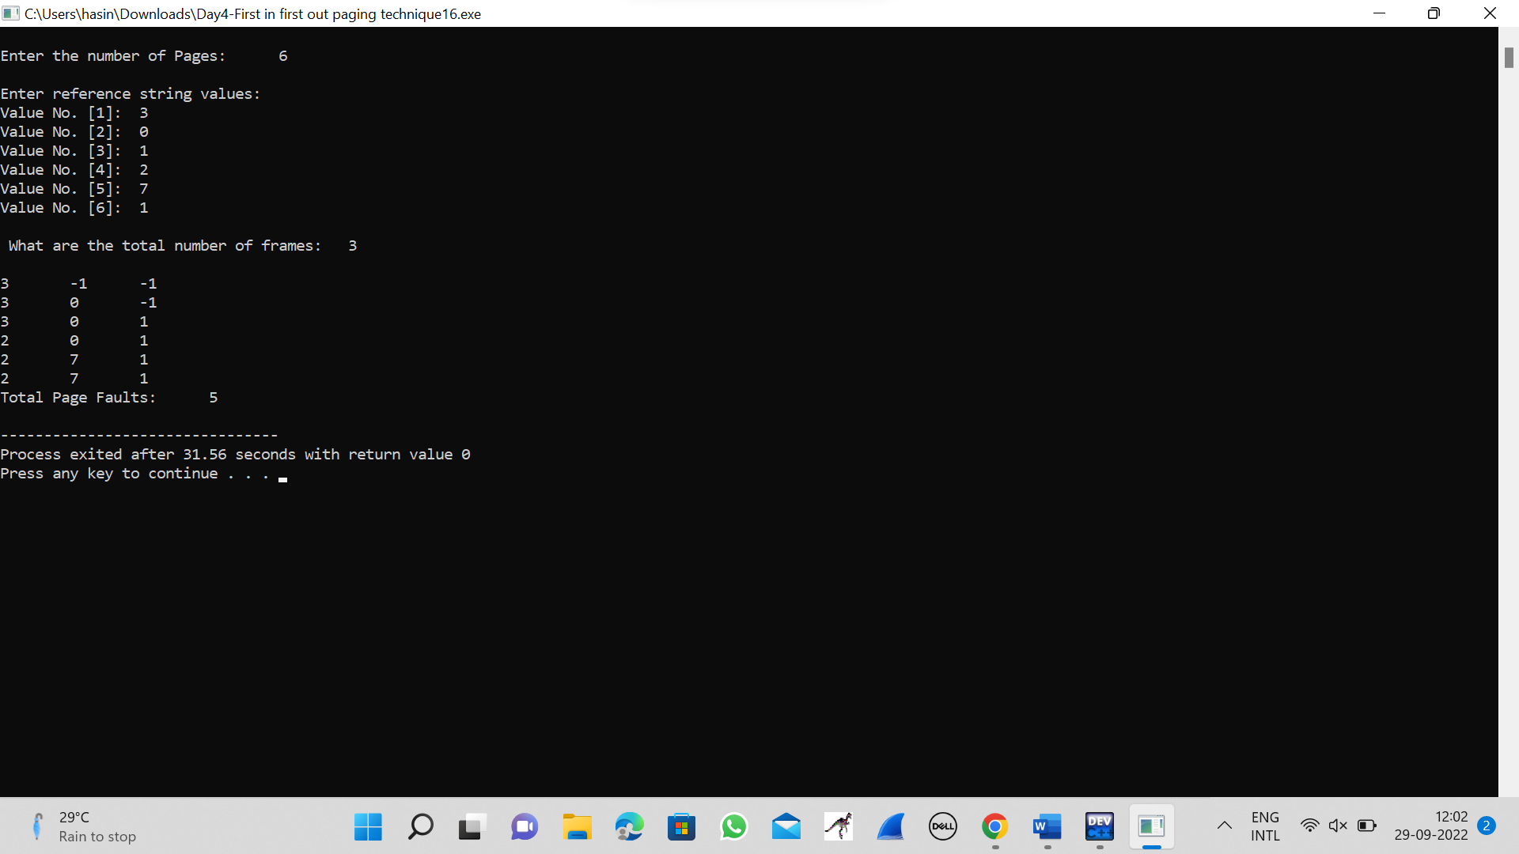

**17.LEAST RECENTLY USED PAGING ALGORITHM**

#include<stdio.h>

int findLRU(int time[], int n){

int i, minimum = time[0], pos = 0;

for(i = 1; i < n; ++i){

if(time[i] < minimum){

minimum = time[i];

pos = i;

}

}

return pos;

}

int main()

{

int no_of_frames, no_of_pages, frames[10], pages[30], counter = 0, time[10], flag1, flag2, i, j, pos, faults = 0;

printf("Enter number of frames: ");

scanf("%d", &no_of_frames);

printf("Enter number of pages: ");

scanf("%d", &no_of_pages);

printf("Enter reference string: ");

for(i = 0; i < no_of_pages; ++i){

scanf("%d", &pages[i]);

}

for(i = 0; i < no_of_frames; ++i){

frames[i] = -1;

}

for(i = 0; i < no_of_pages; ++i){

flag1 = flag2 = 0;

for(j = 0; j < no_of_frames; ++j){

if(frames[j] == pages[i]){

counter++;

time[j] = counter;

flag1 = flag2 = 1;

break;

}

}

if(flag1 == 0){

for(j = 0; j < no_of_frames; ++j){

if(frames[j] == -1){

counter++;

faults++;

frames[j] = pages[i];

time[j] = counter;

flag2 = 1;

break;

}

}

}

if(flag2 == 0){

pos = findLRU(time, no_of_frames);

counter++;

faults++;

frames[pos] = pages[i];

time[pos] = counter;

}

printf("\n");

for(j = 0; j < no_of_frames; ++j){

printf("%d\t", frames[j]);

}

}

printf("\n\nTotal Page Faults = %d", faults);

return 0;

}

**OUTPUT**

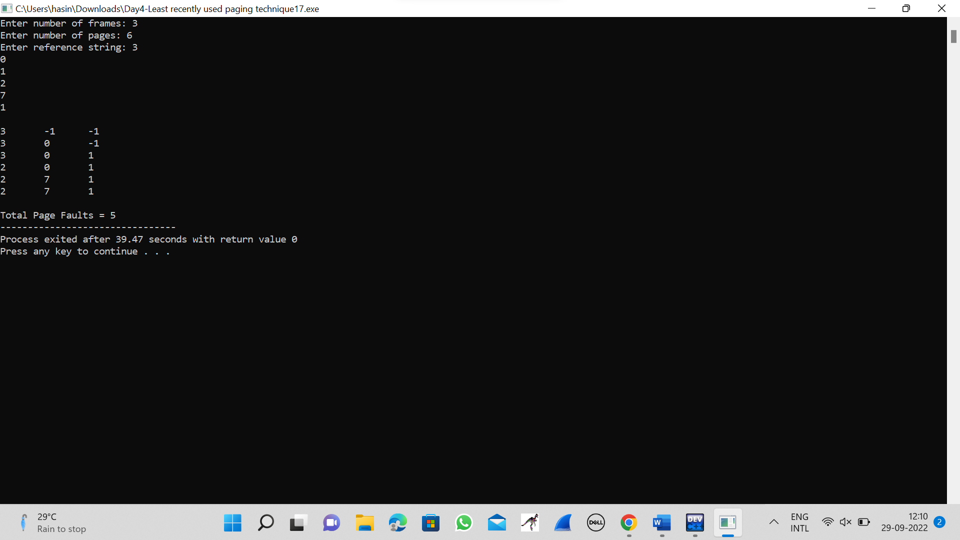

**18.OPTIMAL PAGE ALGORITHM**

#include<stdio.h>

int main()

{

int no_of_frames, no_of_pages, frames[10], pages[30], temp[10], flag1, flag2, flag3, i, j, k, pos, max, faults = 0;

printf("Enter number of frames: ");

scanf("%d", &no_of_frames);

printf("Enter number of pages: ");

scanf("%d", &no_of_pages);

printf("Enter page reference string: ");

for(i = 0; i < no_of_pages; ++i){

scanf("%d", &pages[i]);

}

for(i = 0; i < no_of_frames; ++i){

frames[i] = -1;

}

for(i = 0; i < no_of_pages; ++i){

flag1 = flag2 = 0;

for(j = 0; j < no_of_frames; ++j){

if(frames[j] == pages[i]){

flag1 = flag2 = 1;

break;

}

}

if(flag1 == 0){

for(j = 0; j < no_of_frames; ++j){

if(frames[j] == -1){

faults++;

frames[j] = pages[i];

flag2 = 1;

break;

}

}

}

if(flag2 == 0){

flag3 =0;

for(j = 0; j < no_of_frames; ++j){

temp[j] = -1;

for(k = i + 1; k < no_of_pages; ++k){

if(frames[j] == pages[k]){

temp[j] = k;

break;

}

}

}

for(j = 0; j < no_of_frames; ++j){

if(temp[j] == -1){

pos = j;

flag3 = 1;

break;

}

}

if(flag3 ==0){

max = temp[0];

pos = 0;

for(j = 1; j < no_of_frames; ++j){

if(temp[j] > max){

max = temp[j];

pos = j;

}

}

}

frames[pos] = pages[i];

faults++;

}

printf("\n");

for(j = 0; j < no_of_frames; ++j){

printf("%d\t", frames[j]);

}

}

printf("\n\nTotal Page Faults = %d", faults);

return 0;

}

**OUTPUT**

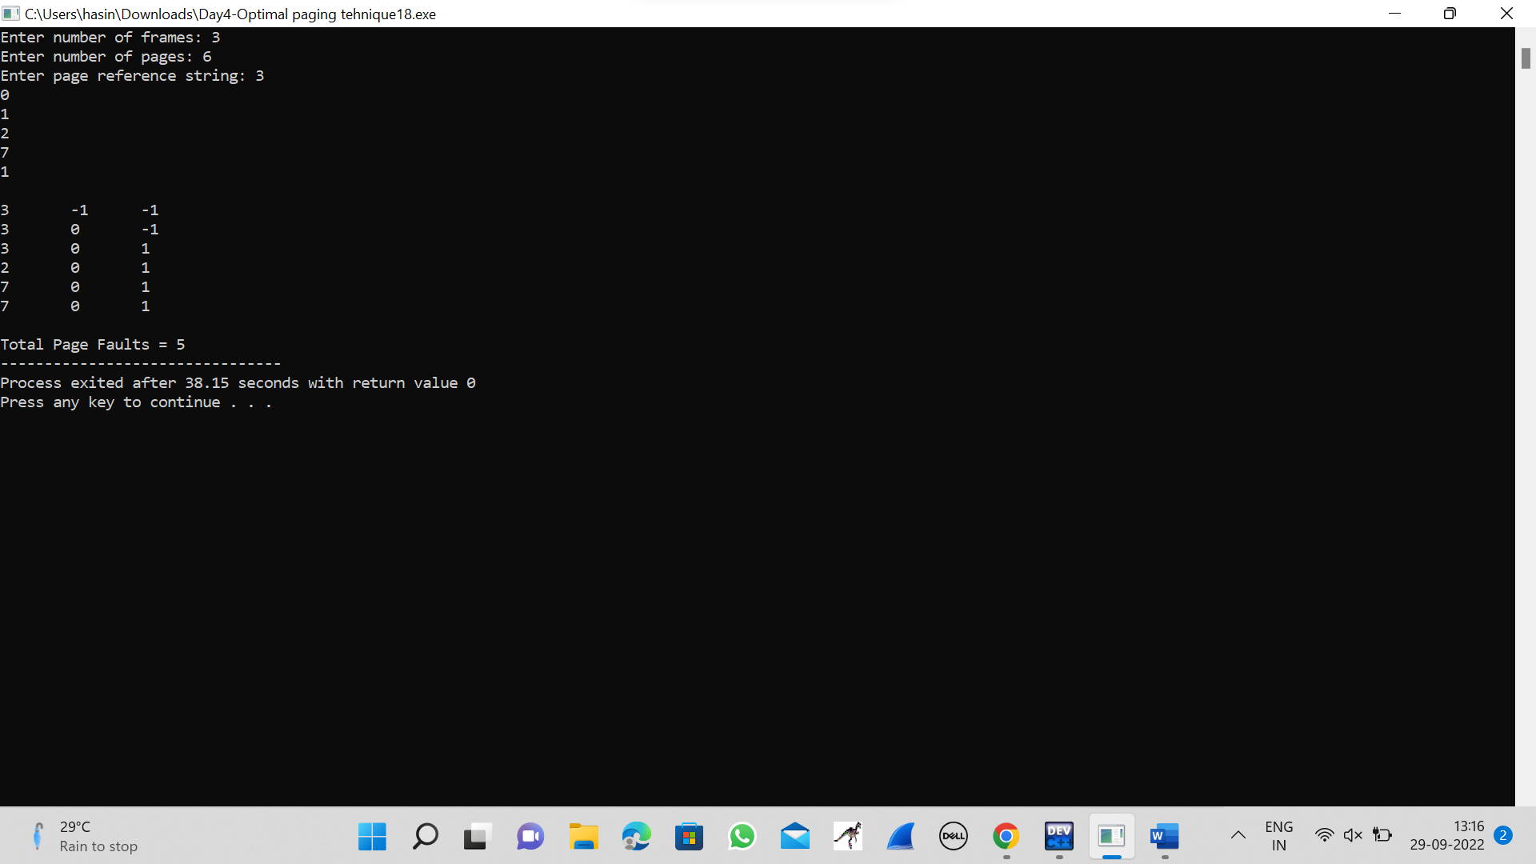

**19.FILE ALLOCATION STATEGY-**Consider a file system where the records of the file are stored one after another both physically and logically. A record of the file can only be accessed by reading all the previous records.  Design a C program to simulate the file allocation strategy.

#include <stdio.h>

#include <stdlib.h>

void recurse(int files[]){

int flag = 0, startBlock, len, j, k, ch;

printf("Enter the starting block and the length of the files: ");

scanf("%d%d", &startBlock, &len);

for (j=startBlock; j<(startBlock+len); j++){

if (files[j] == 0)

flag++;

}

if(len == flag){

for (int k=startBlock; k<(startBlock+len); k++){

if (files[k] == 0){

files[k] = 1;

printf("%d\t%d\n", k, files[k]);

}

}

if (k != (startBlock+len-1))

printf("The file is allocated to the disk\n");

}

else

printf("The file is not allocated to the disk\n");

printf("Do you want to enter more files?\n");

printf("Press 1 for YES, 0 for NO: ");

scanf("%d", &ch);

if (ch == 1)

recurse(files);

else

exit(0);

return;

}

int main()

{

int files[50];

for(int i=0;i<50;i++)

files[i]=0;

printf("Files Allocated are :\n");

recurse(files);

getchar();

return 0;

}

**OUTPUT**

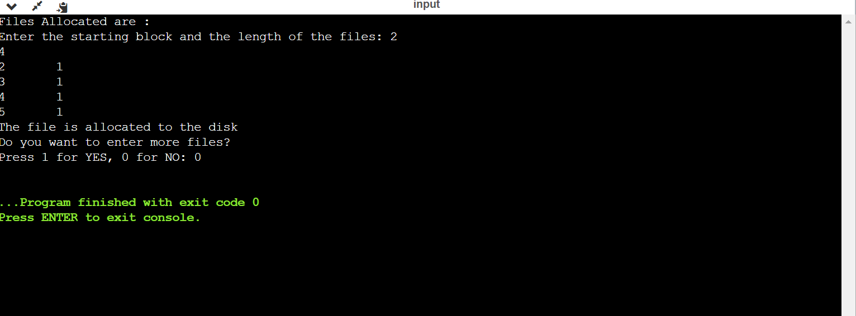

**20.INDEX FILE ORGANIZATION-** Consider a file system that brings all the file pointers together into an index block. The ith entry in the index block points to the ith block of the file. Design a C program to simulate the file allocation strategy.

#include<stdio.h>

#include<conio.h>

#include<stdlib.h>

void main()

{

int f[50], index[50],i, n, st, len, j, c, k, ind,count=0;

for(i=0;i<50;i++)

f[i]=0;

x:printf("Enter the index block: ");

scanf("%d",&ind);

if(f[ind]!=1)

{

printf("Enter no of blocks needed and no of files for the index %d on the disk : \n", ind);

scanf("%d",&n);

}

else

{

printf("%d index is already allocated \n",ind);

goto x;

}

y: count=0;

for(i=0;i<n;i++)

{

scanf("%d", &index[i]);

if(f[index[i]]==0)

count++;

}

if(count==n)

{

for(j=0;j<n;j++)

f[index[j]]=1;

printf("Allocated\n");

printf("File Indexed\n");

for(k=0;k<n;k++)

printf("%d-------->%d : %d\n",ind,index[k],f[index[k]]);

}

else

{

printf("File in the index is already allocated \n");

printf("Enter another file indexed");

goto y;

}

printf("Do you want to enter more file(Yes - 1/No - 0)");

scanf("%d", &c);

if(c==1)

goto x;

else

exit(0);

getch();

}

**OUTPUT**

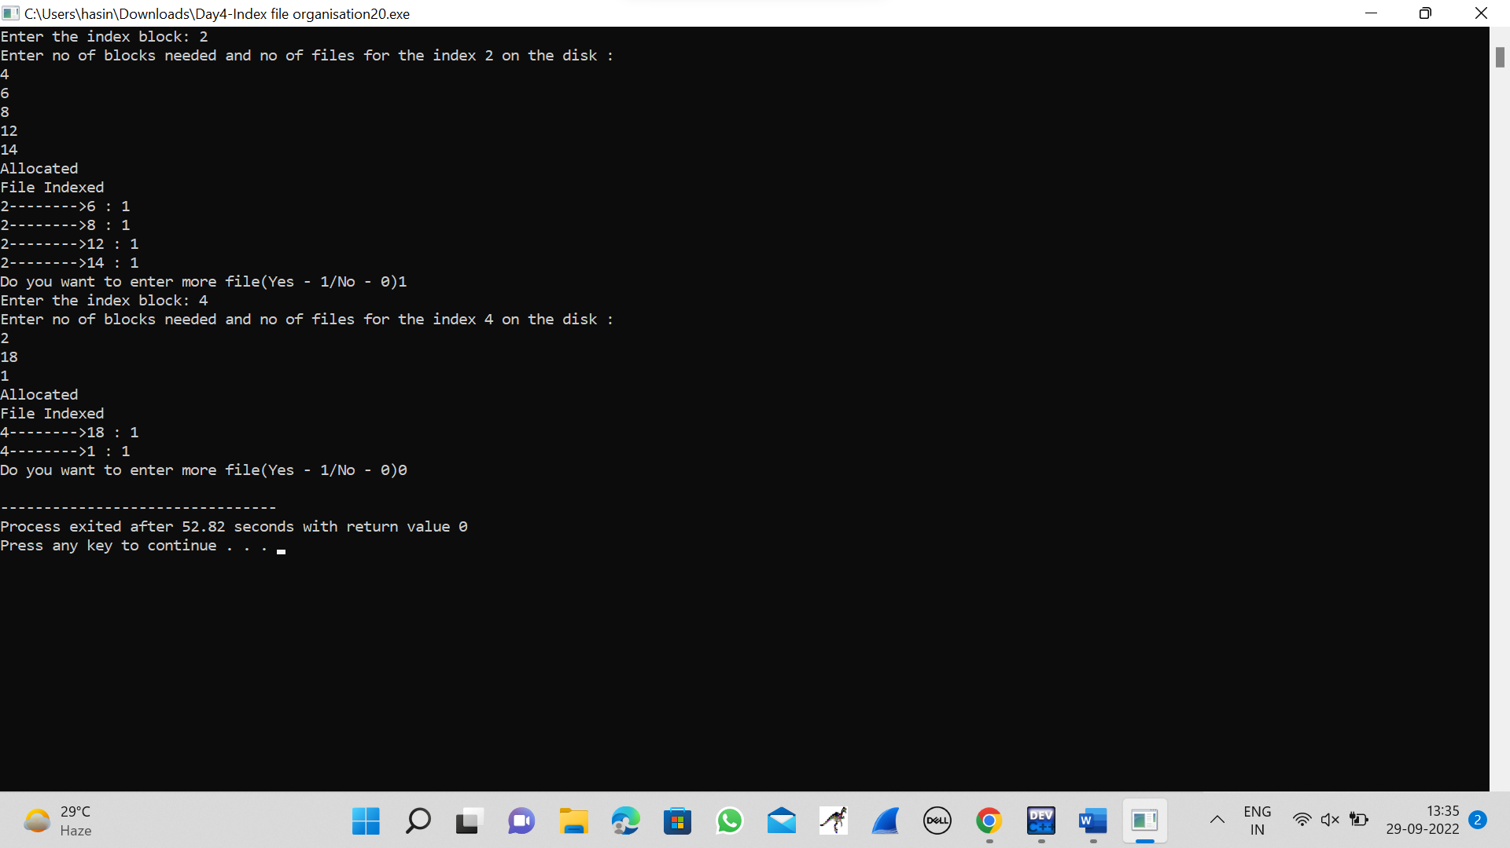

**21.** **FILE ALLOCATTION STRATEGY**- With linked allocation, each file is a linked list of disk blocks; the disk blocks may be scattered anywhere on the disk. The directory contains a pointer to the first and last blocks of the file.  Each block contains a pointer to the next block. Design a C program to simulate the file allocation strategy.

#include<stdio.h>

#include<conio.h>

#include<stdlib.h>

int main()

{

int f[50], p,i, st, len, j, c, k, a;

for(i=0;i<50;i++)

f[i]=0;

printf("Enter how many blocks already allocated: ");

scanf("%d",&p);

printf("Enter blocks already allocated: ");

for(i=0;i<p;i++)

{

scanf("%d",&a);

f[a]=1;

}

x: printf("Enter index starting block and length: ");

scanf("%d%d", &st,&len);

k=len;

if(f[st]==0)

{

for(j=st;j<(st+k);j++)

{

if(f[j]==0)

{

f[j]=1;

printf("%d-------->%d\n",j,f[j]);

}

else

{

printf("%d Block is already allocated \n",j);

k++;

}

}

}

else

printf("%d starting block is already allocated \n",st);

printf("Do you want to enter more file(Yes - 1/No - 0)");

scanf("%d", &c);

if(c==1)

goto x;

else

exit(0);

getchar();

}

**OUTPUT**

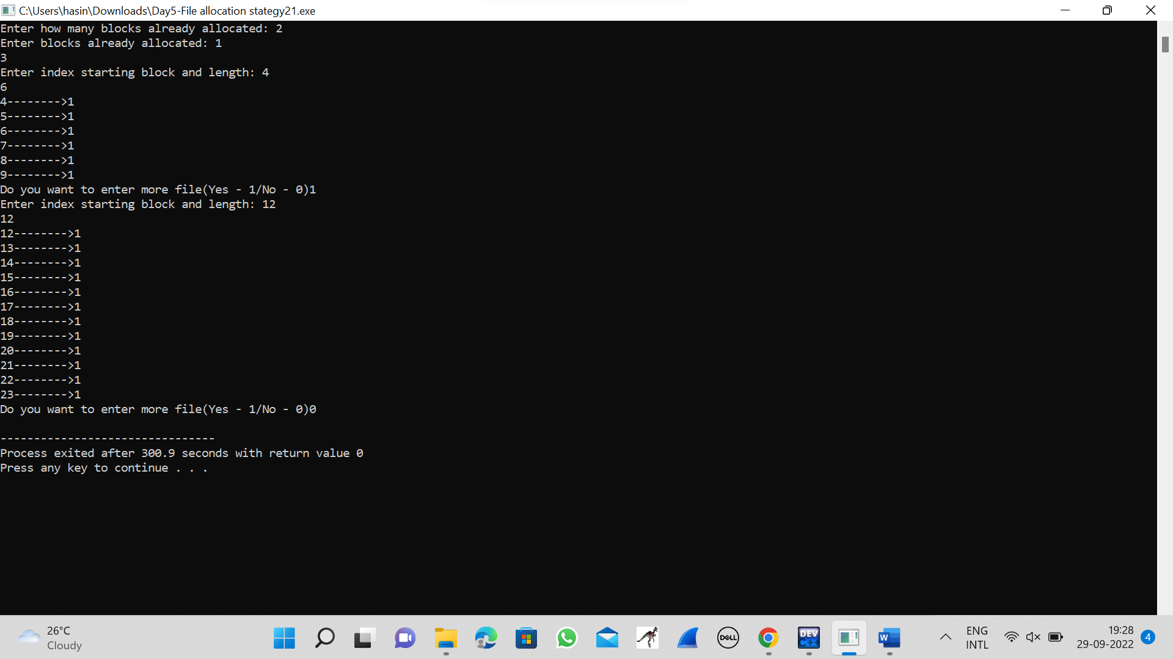

**22.FIRST COME FIRST SEVED DISK SCHEDULLING ALGORITHM**

#include<stdio.h>

#include<stdlib.h>

int main()

{

int RQ[100],i,n,TotalHeadMoment=0,initial;

printf("Enter the number of Requests\n");

scanf("%d",&n);

printf("Enter the Requests sequence\n");

for(i=0;i<n;i++)

scanf("%d",&RQ[i]);

printf("Enter initial head position\n");

scanf("%d",&initial);

for(i=0;i<n;i++)

{

TotalHeadMoment=TotalHeadMoment+abs(RQ[i]-initial);

initial=RQ[i];

}

printf("Total head moment is %d",TotalHeadMoment);

return 0;

}

**OUTPUT**

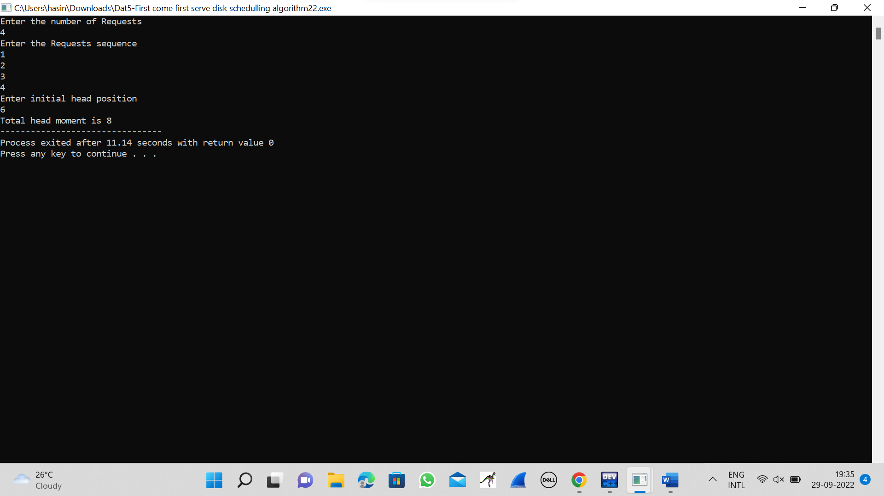

**23.SCAN DISK SCHEDULLING ALGORITHM**

#include<stdio.h>

int request[50];

int SIZE;

int pre;

int head;

int uptrack;

int downtrack;

struct max{

int up;

int down;

}kate[50];

int dist(int a,int b)

{

if(a>b)

return a-b;

return b-a;

}

void sort(int n)

{

int i,j;

for (i = 0; i < n-1; i++)

{

for (j = 0; j < n-i-1; j++)

{

if (request[j] > request[j+1])

{

int temp=request[j];

request[j]=request[j+1];

request[j+1]=temp;

}

}

}

j=0;

i=0;

while(request[i]!=head)

{

kate[j].down=request[i];

j++;

i++;

}

downtrack=j;

i++;

j=0;

while(i<n)

{

kate[j].up=request[i];

j++;

i++;

}

uptrack=j;

}

void scan(int n)

{

int i;

int seekcount=0;

printf("SEEK SEQUENCE = ");

sort(n);

if(pre<head){

for(i=0;i<uptrack;i++)

{

printf("%d ",head);

seekcount=seekcount+dist(head,kate[i].up);

head=kate[i].up;

}

for(i=downtrack-1;i>0;i--)

{

printf("%d ",head);

seekcount=seekcount+dist(head,kate[i].down);

head=kate[i].down;

}

}

else

{

for(i=downtrack-1;i>=0;i--)

{

printf("%d ",head);

seekcount=seekcount+dist(head,kate[i].down);

head=kate[i].down;

}

for(i=0;i<uptrack-1;i++)

{

printf("%d ",head);

seekcount=seekcount+dist(head,kate[i].up);

head=kate[i].up;

}

}

printf(" %d\nTOTAL DISTANCE :%d",head,seekcount);

}

int main()

{

int n,i;

printf("ENTER THE DISK SIZE :\n");

scanf("%d",&SIZE);

printf("ENTER THE NO OF REQUEST SEQUENCE :\n");

scanf("%d",&n);

printf("ENTER THE REQUEST SEQUENCE :\n");

for(i=0;i<n;i++)

scanf("%d",&request[i]);

printf("ENTER THE CURRENT HEAD :\n");

scanf("%d",&head);

request[n]=head;

request[n+1]=SIZE-1;

request[n+2]=0;

printf("ENTER THE PRE REQUEST :\n");

scanf("%d",&pre);

scan(n+3);

}

**OUTPUT**

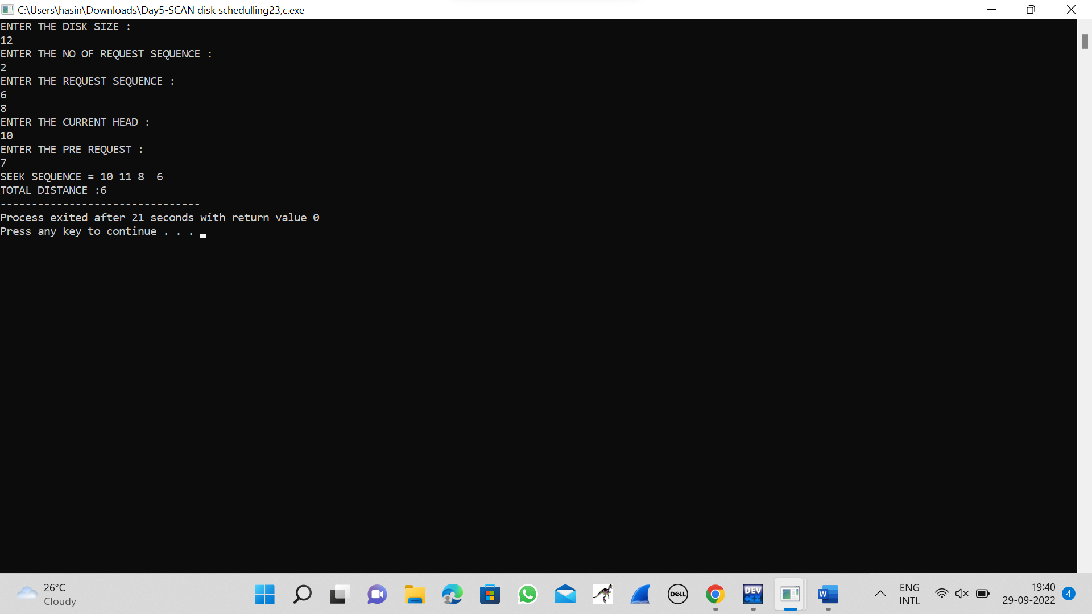

**24.C-SACN DISK SCHEDULLING ALGORITHM**

#include <stdlib.h>

int main(){

int RQ[100], i, j, n, TotalHeadMoment = 0, initial, size, move;

printf("Enter the number of Requests\n");

scanf("%d", &n);

printf("Enter the Requests sequence\n");

for (i = 0; i < n; i++)

scanf("%d", &RQ[i]);

printf("Enter initial head position\n");

scanf("%d", &initial);

printf("Enter total disk size\n");

scanf("%d", &size);

printf("Enter the head movement direction for high 1 and for low 0\n");

scanf("%d", &move);

for (i = 0; i < n; i++){

for (j = 0; j < n - i - 1; j++){

if (RQ[j] > RQ[j + 1]){

int temp;

temp = RQ[j];

RQ[j] = RQ[j + 1];

RQ[j + 1] = temp;

}

}

}

int index;

for (i = 0; i < n; i++){

if (initial < RQ[i]){

index = i;

break;

}

}

if (move == 1){

for (i = index; i < n; i++){

TotalHeadMoment = TotalHeadMoment + abs(RQ[i] - initial);

initial = RQ[i];

}

TotalHeadMoment = TotalHeadMoment + abs(size - RQ[i - 1] - 1);

TotalHeadMoment = TotalHeadMoment + abs(size - 1 - 0);

initial = 0;

for (i = 0; i < index; i++){

TotalHeadMoment = TotalHeadMoment + abs(RQ[i] - initial);

initial = RQ[i];

}

}

else{

for (i = index - 1; i >= 0; i--){

TotalHeadMoment = TotalHeadMoment + abs(RQ[i] - initial);

initial = RQ[i];

}

TotalHeadMoment = TotalHeadMoment + abs(RQ[i + 1] - 0);

TotalHeadMoment = TotalHeadMoment + abs(size - 1 - 0);

initial = size - 1;

for (i = n - 1; i >= index; i--){

TotalHeadMoment = TotalHeadMoment + abs(RQ[i] - initial);

initial = RQ[i];

}

}

printf("Total head movement is %d", TotalHeadMoment);

return 0;

}

**OUTPUT**

